How to import a digital certificate (.p12 or .pfx file) into Outlook
- In Outlook Click the File > Options
- In the Outlook Options dialog box, click the Trust Center in the left bar
- Click the Trust Center Settings button.
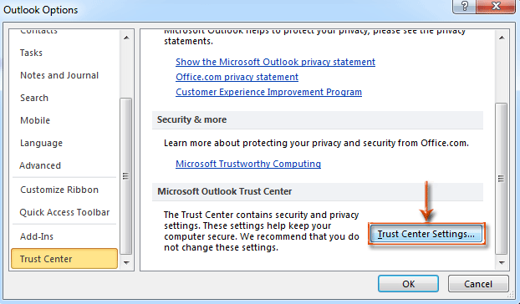

Step 2: In the Trust Center dialog box, click the E-mail Security in the left bar.
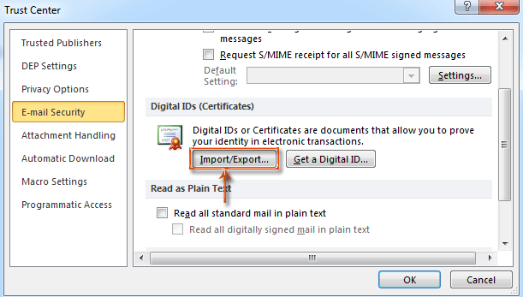
Step 3: Go to the Digital IDs (Certificates) section, and click the Import / Export button.
Step 4: In the Import / Export Digital ID dialog box:
Import Digital ID or certificate
- First, click the Import existing Digital ID from a file option.
- Then click the Browse button, and in the Locate Security Profile dialog box select a Digital ID (this will be the .P12 file you downloaded from DigiCert and created a password for on their website), and then click the Open button.
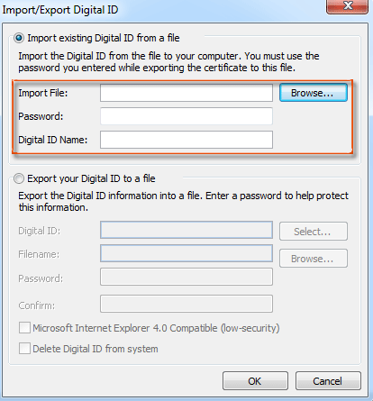
- Enter the password in the Password: box.
- Enter a name in the Digital ID Name: box.

Step 5: Click OK to set the security level if prompted.

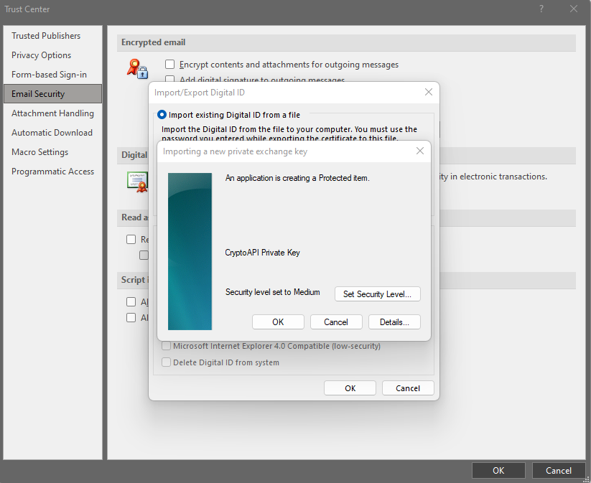

Step 6: Configure the certificate for use
- Click Settings to configure Outlook to use the certificate.
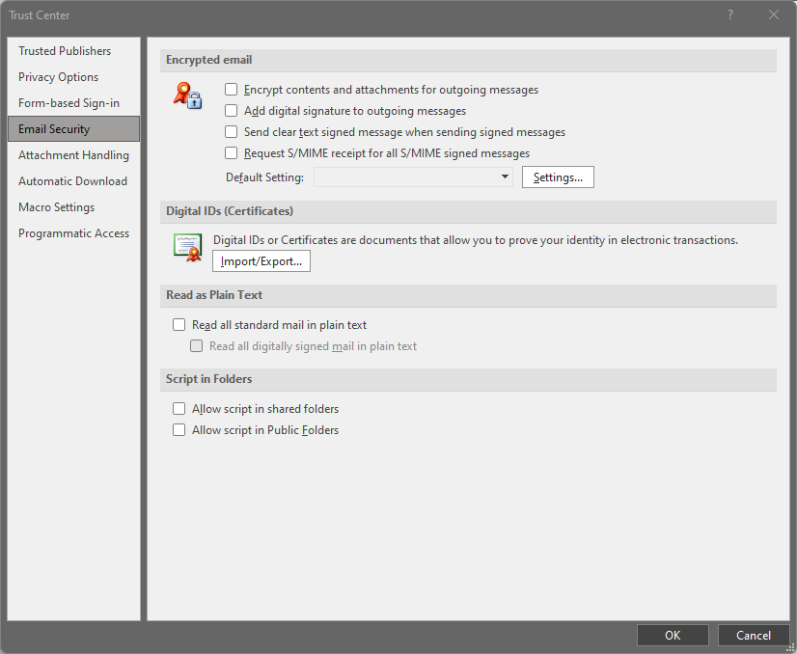
- Enter a name for the Security Settings Name, it can be whatever makes sense to you
- Click on the top Choose button and then click OK on the Select a Certificate window. The newly imported certificate should be the only option, but if you get multiple certificates to choose from, select the one from DigiCert that’s dated the day you downloaded the certificate.
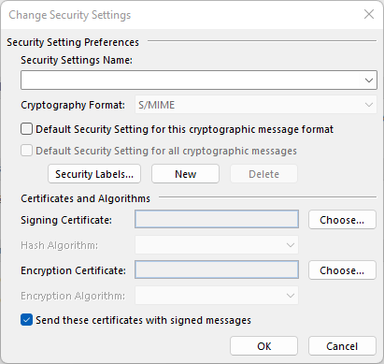

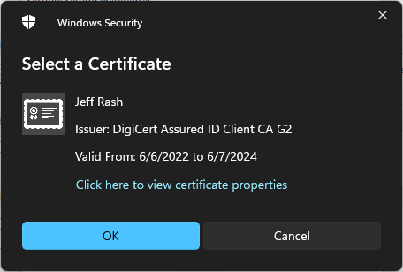

- Change the Hash Algorithm to be SHA265 and then click OK
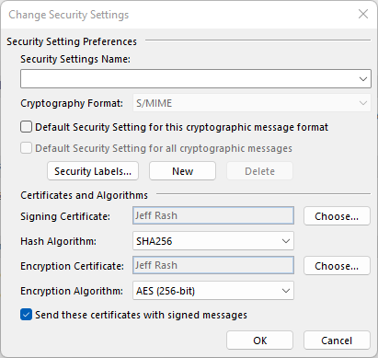
- Click OK to complete the process.
